Reading Strategies GLA, Part 1

Worksheet

This workshop will help you learn various strategies to improve your active reading skills, including:

1. Think Aloud
2. Talk to the Text
3. SQ3R: Survey, Question, Read, Recite, Review
4. Look-away method

**What Is Active Reading?**

Active reading occurs when we read with purpose. In other words, our goal is to learn the material (not just finish the pages) and connect that material to our needs. We know that we’re reading actively when we are:

* Interacting with the reading (previewing the material, taking notes, predicting, etc.)
* Critically thinking about the author’s ideas
* Considering our own ideas as we read

**Strategy 1: Think Aloud**

The Think Aloud strategy allows students to hear other readers’ strategies and practice some of their own strategies out loud. To complete a Think Aloud, read a passage out loud. As you read, explain how you are figuring out what the passage means. By completing a Think Aloud, we make our normally-silent strategies **audible.** We can hear how other readers approach a text, and share our own strategies with other readers.



***Sample Think Aloud***

*Instructions: As you watch the sample Think Aloud video, make note of the strategies and phrases that the reader is using. Use the list of strategies and phrases below to help you.*

The sample Think Aloud is available at <https://www.youtube.com/watch?v=Q3ZkKNuPp_I>. Or, you can scan the QR code on the right.

|  |  |
| --- | --- |
| **Common Reading Strategies:**   1. Preview the text to note title, headings, subheadings, and illustrations. 2. Make connections to the text with prior knowledge and experience. 3. Create a list, image, or picture of the text, either mentally or on paper. 4. Confront unfamiliar vocabulary using context clues and root words. 5. Come back to the text when drifting. 6. Tolerate ambiguity. (Be willing to read on even if text isn’t perfectly clear yet.) 7. Reread sections to clear up confusion. (Know when to reread or when to move on.) 8. Predict what is to come in the text. 9. Question the author. 10. Summarize or paraphrase material in own words. | **Helpful Phrases:**   1. I predict that… 2. I can picture… 3. A question I have is… 4. This is like… 5. This reminds me of… 6. I am confused about… 7. I will reread this… 8. The big idea here is… 9. I think/believe/wonder… 10. The author wants me to… 11. The author’s biases are… |

|  |
| --- |
| ***What strategies and phrases does the reader use during the sample Think Aloud video?*** |

**Strategy 2: Talk to the Text**

Talking to the Text is very similar to a Think Aloud. Instead of speaking out loud, you will practice your common reading strategies **in writing** on a text. This exercise is called Talking to the Text because you have an unspoken conversation with the reading.

There are several steps you can take to talk to the text effectively.

1. Use the common reading strategies and helpful phrases that we practiced in the Think Aloud.
2. Make connections between the reading and information you already know.
3. Make predictions about where the reading may be going.
4. Make note of unfamiliar vocabulary and any other questions you may have.
5. Annotate your text thoroughly (consider attending the Annotation Workshop for more information).

***Sample Talk to the Text***

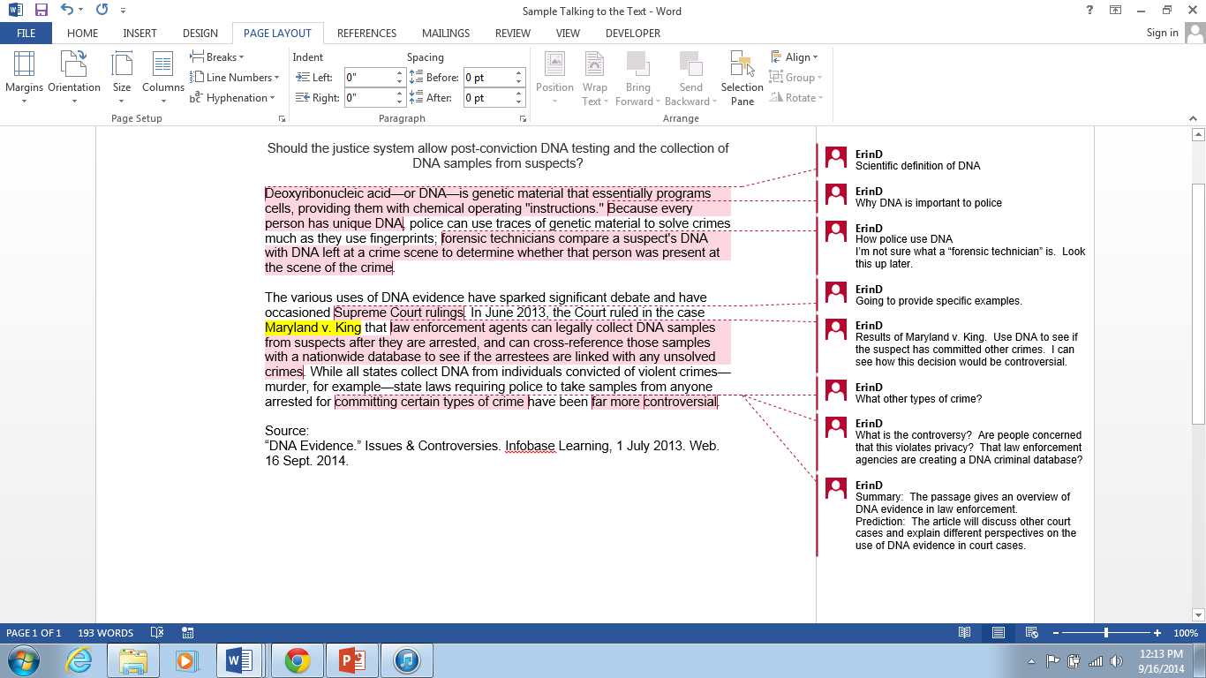

*Instructions: Complete a Talk to the Text on your own using Reading A. Read the passage, making frequent notes. Be sure to consider:*

* *Common reading strategies and helpful phrases*
* *Connections to information you already know*
* *Predictions of where the text is going*
* *Unfamiliar vocabulary/questions*

**Reading A: “Should classroom animal dissection be mandatory?”**

|  |
| --- |
| “As of early 2007, animal dissection requirements are not in danger of being abolished at the national level. In fact, some six million animals are dissected in the nation's schools every year, according to the Humane Society of the United States (HSUS), a nonprofit animal-rights organization based in Washington, D.C. Nevertheless, it is unquestioned that recent student protests against the practice have made an impact on educational policy in some areas: Fourteen states now allow students to opt out of in-class dissection if operating on an animal is personally objectionable to them.” |

Source:

“Animal Dissection.” Issues & Controversies. Infobase Learning, 12 Jan. 2007. Web. 16 Sept. 2014.

**Strategy 3: SQ3R: Survey, Question, Read, Recite, Review**

**Survey:** Before you begin reading, survey the text. This means you should flip through the text, making note of:

* The title, headings, and subheadings
* Captions under pictures, charts, graphs, or maps
* Review questions in the text or study guides made by the teacher
* Introduction and Conclusion paragraphs
* Chapter summary

**Question:** As you survey the text, ask questions.

* Ask yourself, “what do I already know about this topic?’
* Ask yourself, “what did my instructor say about this reading when it was assigned?”
* Turn the title, headings, and subheadings into questions
* Read any review questions that appear in the text

**Read:** After surveying and questioning, begin reading the text. While reading, you should:

* Look for the answers to the questions you created
* Answer the review questions in the text
* Reread captions under pictures, graphs, etc.
* Note any words or phrases in bold or italics
* Study any graphic aids
* Slow down for difficult passages
* Reread passages that aren’t clear

*\*Recite and Review are discussed below*

***Sample Survey, Question, and Read***

The sample is based on CDC’s “College Health and Safety” website, which is available at <http://www.cdc.gov/family/college/>. You can also scan the QR code to access the site.

*Instructions:* Read through the sample Survey, Question, and Read below. When you reach the heading “Prevent Sexually Transmitted Diseases,” you will complete the Question and Read boxes yourself.

|  |  |  |
| --- | --- | --- |
| **Survey** | **Question** | **Read** |
| Title: College Health and Safety | What health and safety issues apply specifically to college students? | * Exercise * Diet * Sexually Transmitted Diseases (STDs) * Vaccinations * Sleep * Mental Health * Harmful Substances (drugs, alcohol, and cigarettes) * Campus Security * Sexual Violence |
| Heading: Move It | What does it mean to move it?  How much exercise should college students get?  Why is exercise important? | Move it=Exercise  Students should get 2½ hours of physical activity a week  Exercise helps students improve health and reduces risk for chronic conditions like diabetes. |
| Heading: Balance Your Diet | What should college students be eating?  What should students avoid?  What happens if students have an unbalanced diet? | College students should eat fruit and vegetables, not the junk food that is easily available on campus.  Students may not eat enough due to stress. |
| Heading: Prevent Sexually Transmitted Diseases |  |  |

**Recite:** After each section, stop and recite what you learned. You should:

* Summarize the text out loud
* Write notes about the reading in your own words
* Underline or highlight important points

**Review:** Review should take place frequently after you have completed a reading to ensure that you remember the information. When you review, you should:

* Ask and answer questions about the important points that you identified
* Reread the notes you wrote about the text
* Make flash cards to help memorize difficult concepts
* Create your own study guide for the chapter
* Review the study guide to prepare for an exam

**Strategy 4: The Look-Away Method**

The Look-Away Method asks you to test yourself as you complete a reading. Periodically, look away from the reading to ask yourself questions about the material. You should:

* Briefly summarize the material
* Ask and answer sample test questions about the material
* Respond to the material: Do you agree or disagree? Why?
* Make connections to the material: How does it relate to what you already know? To your assignment? Your major? Your career?

As you complete the above steps, write notes for yourself in the margins or in your notebook. This will help you remember the material better.

***Sample Look-Away***

*Instructions:* When you are done reading the passage on Angkor Wat, do a sample Look-Away using at least one of the above strategies. Write your answer below.

|  |
| --- |
|  |

Self-Reflection

Write a brief paragraph (3-5 sentences) answering the following questions:

* What did you learn about your own reading process from today’s activities?
* What strategies do you plan to use when facing a challenging text? Why?